**SBM2S**

project for 321swe course

2017/april/9

Phase1

Role responsibilities:

|  |  |
| --- | --- |
| **Student Name** | **Responsibilities** |
| Norah alkhunifer | Add driver and view rout use case+state machine diagram +MVC’s+block diagram |
| Raghad alsaleh | Inform absence use case +class diagram + Use case diagram |
| Reema al-swailam | Confirm use case+ mockups + Q9 |

**Use case diagram :**

**1**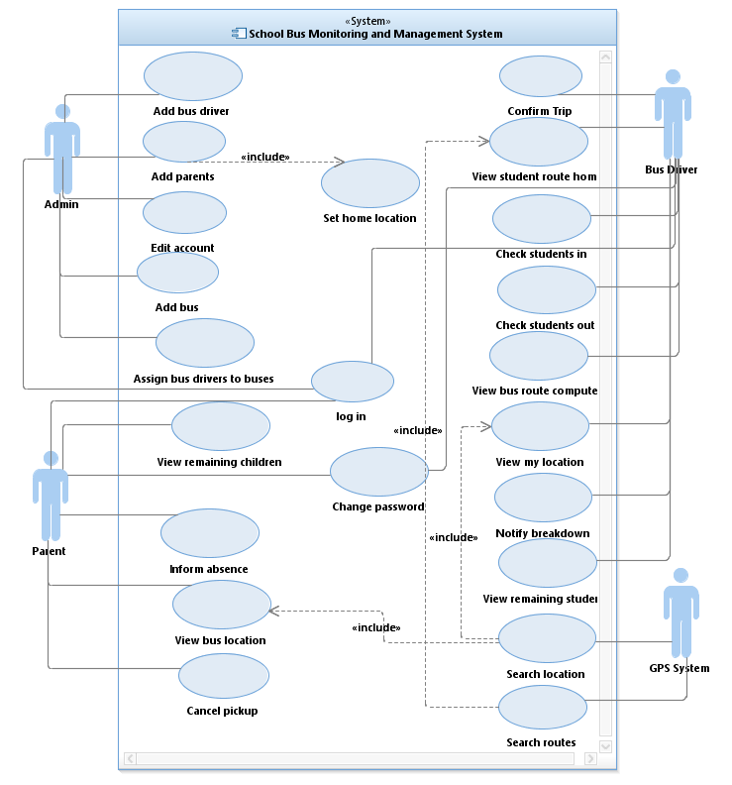

**1st use case ,Add Bus Driver:**

*Use case description :*

|  |  |  |
| --- | --- | --- |
|  | | |
| **SYSTEM: The School Bus Monitoring and Management System (SBM2S)** | | |
| **USE CASE NAME: Add bus driver** | | |
| **PRIMARY ACTOR: admin** | **SECONDARY ACTOR(S): bus driver** | |
| **DESCRIPTION: this use case describe how the admin can register a new bus driver on SBM2S.** | | |
| **RELATIONSHIPS INCLUDES:  EXTENDS:** | | |
| **PRE-CONDITION: The admin logged in successfully** | | |
|  | | |
| **PRIMARY ACTOR (admin)** | **SYSTEM** | **SECONDARY ACTOR ( bus driver )** |
| **1.1 the admin clicks on add bus driver button 1.3 the admin fills the form. 1.4 the admin assign bus driver to bus .**  **1.5 the admin clicks on add button .** | **1.2 the system show a form to the admin.**  **1.6 the system sends to the bus-driver message with the unique user name and password.**  **1.7 the system save changes and sends the admin to home page and display a successful adding message.** | **1.8 the bus-driver receives the message with his /her information.** |
| **ALTERNATIVE AND EXCEPTIONAL FLOWS:  1.Missing Field/ Incorrect Format**  **If in step 1.3 the admin misses a required field or enters a field in incorrect format, then:**  **the system displays a message indicating required fields or format.**  **2. Admin quits**  **If at any step before step 1.7 the admin closes the page**  **The use case ends with a failure condition** | | |
| **POST-CONDITIONS:**  **Successful condition: the system adds the bus-driver and save all of his information successfully  Failure Condition: no bus-driver added to the system.** | | |

*Sequence diagram:*

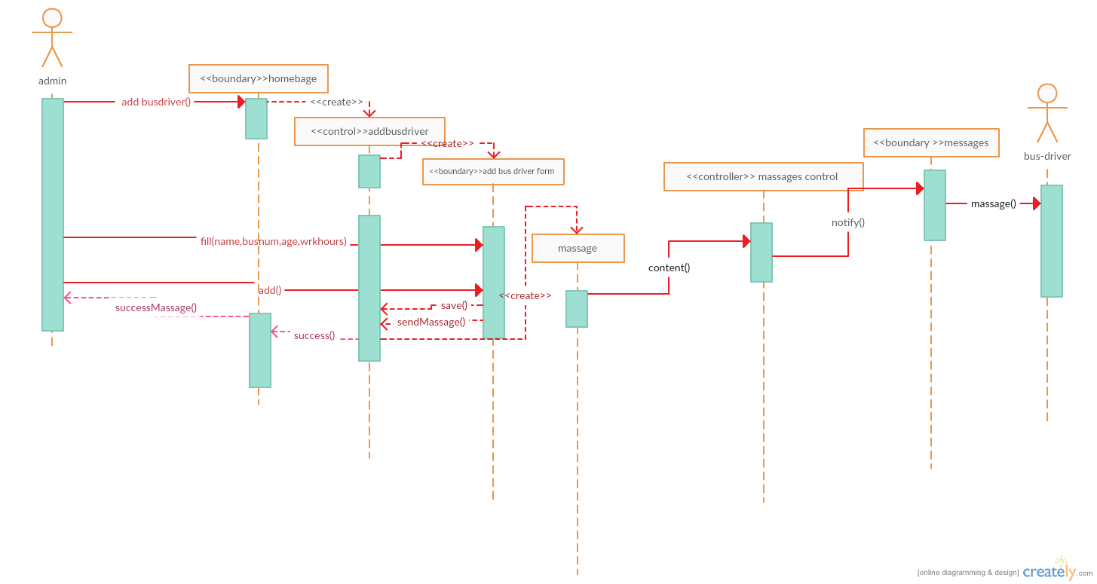1.1.1 add bus driver sequence diagram

*VOPC diagram :*

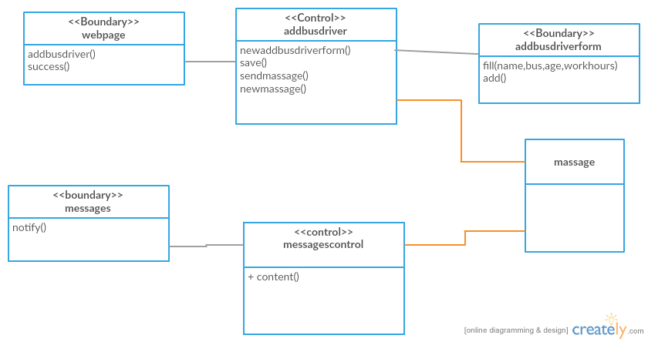1.1.2 add bus driver VOPC diagram

*Mock-ups:*

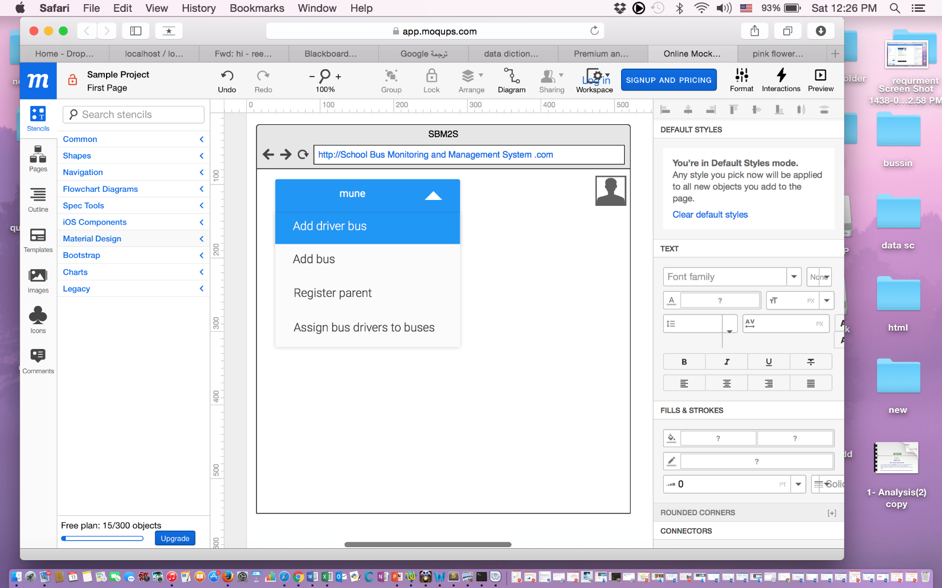

1.1.3 clicking on add bus driver

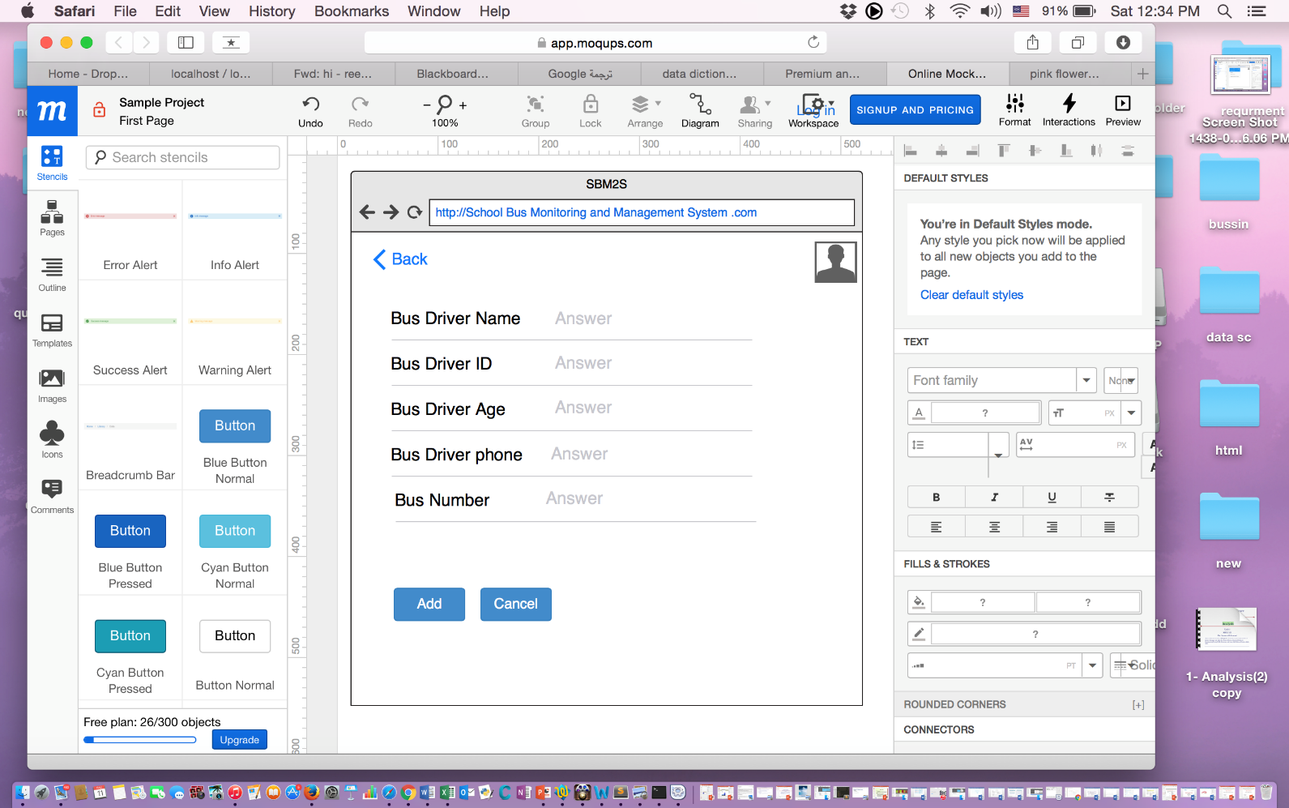

1.1.4fill bus driver info and click add button 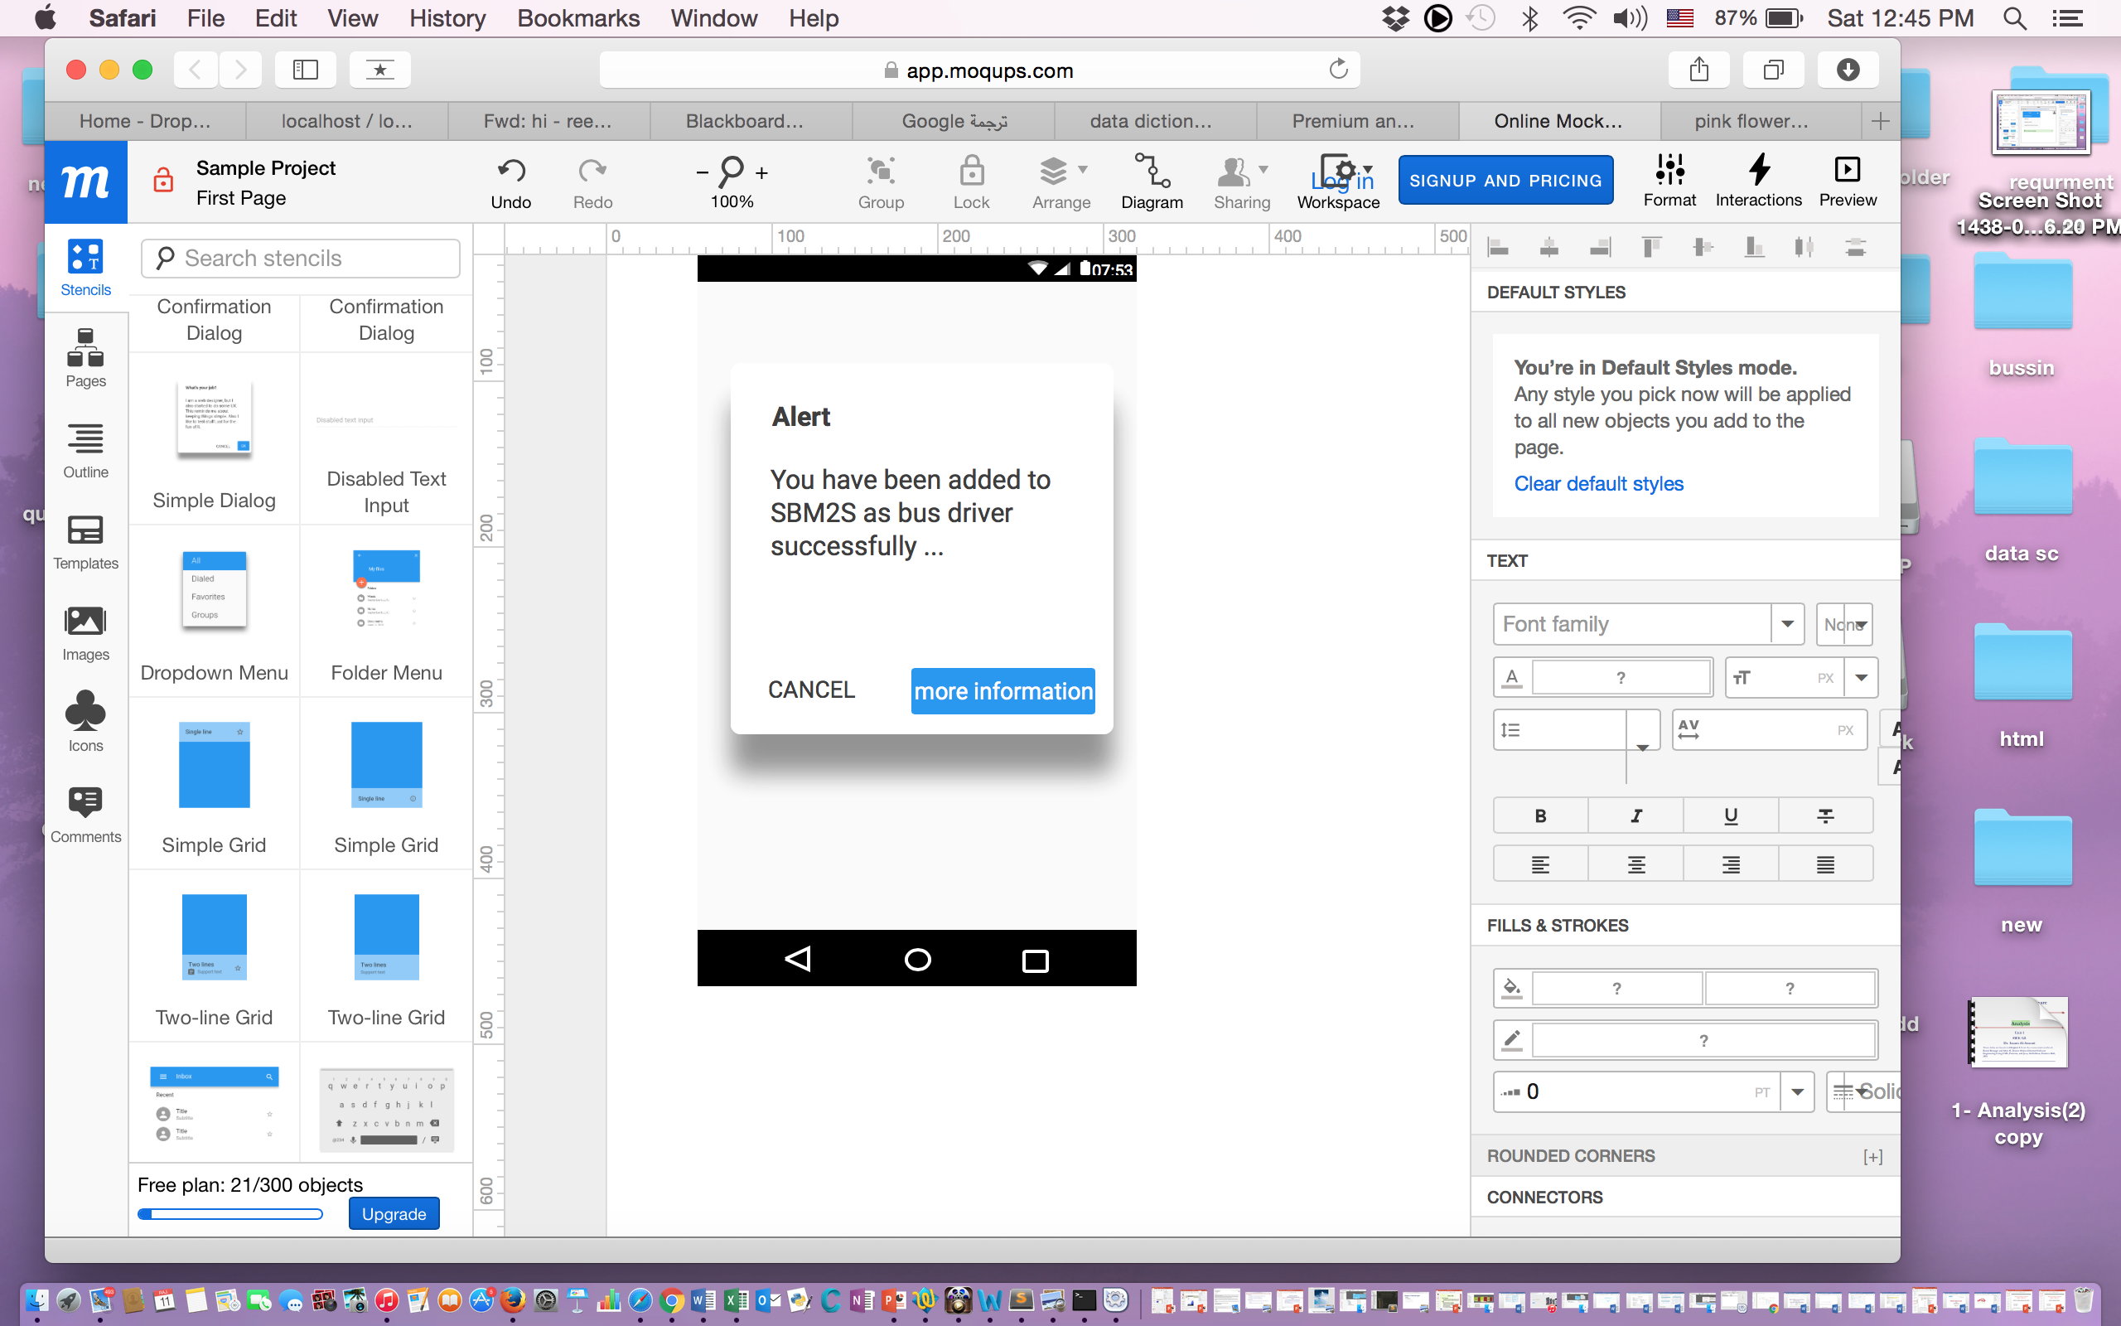

1.1.5massage is sent to the bus driver with username and password

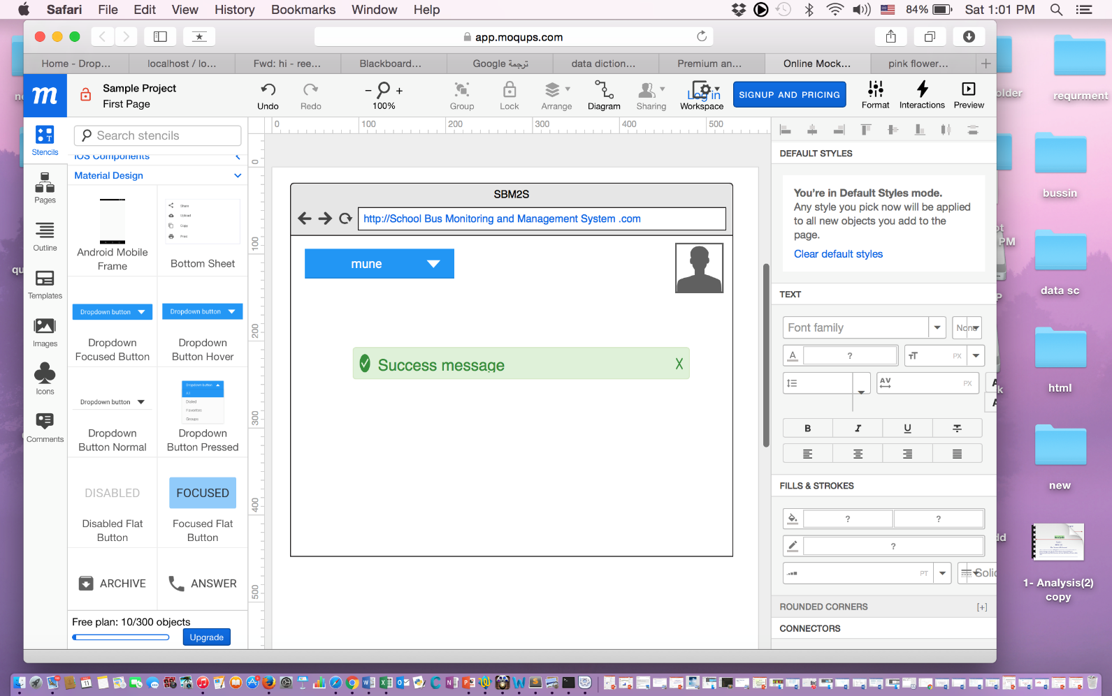

1.1.6 add bus driver is completely done

**2nd use case , Confirm Trip:**

*Use case description :*

|  |  |  |
| --- | --- | --- |
|  | | |
| **SYSTEM: The School Bus Monitoring and Management System (SBM2S)** | | |
| **USE CASE NAME:**  **confirm trip** | | |
| **PRIMARY ACTOR: bus driver** | **SECONDARY ACTOR(S):**  **-** | |
| **DESCRIPTION:**  **this use case Describes how registered bus driver can confirm a trip** | | |
| **RELATIONSHIPS INCLUDES:  EXTENDS:** | | |
| **PRE-CONDITION:  the bus driver shall log in successfully** | | |
|  | | |
| **PRIMARY ACTOR (admin)** | **SYSTEM** | **SECONDARY ACTOR (- )** |
| **1.1 the bus driver press on the "confirm trip "option. 1.3 the bus driver select specific trip. 1.4 the bus driver press confirm button.** | **1.2 the system display list of available trips.**  **1.5 the system display successful message .** |  |
| **ALTERNATIVE AND EXCEPTIONAL FLOWS:  1.Missing the connection**  **If in network is missing the use case end with failure condition .**  **2. No trips created**  **If the trip list is empty the system shall display a notifay message to bus driver** | | |
| **POST-CONDITIONS:**  **the system display successful message to bus-driver and the trip confirmed successfully** | | |

*Sequence diagram:*

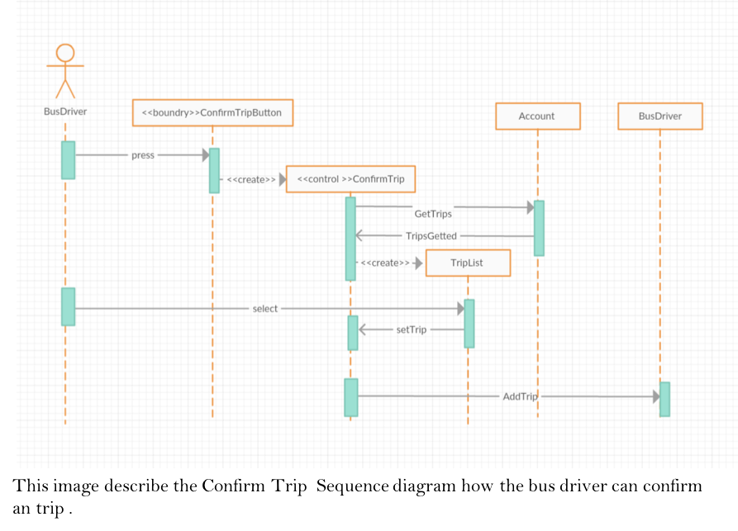

1.2.1 confirm Trip sequence diagram

*VOPC diagram :*

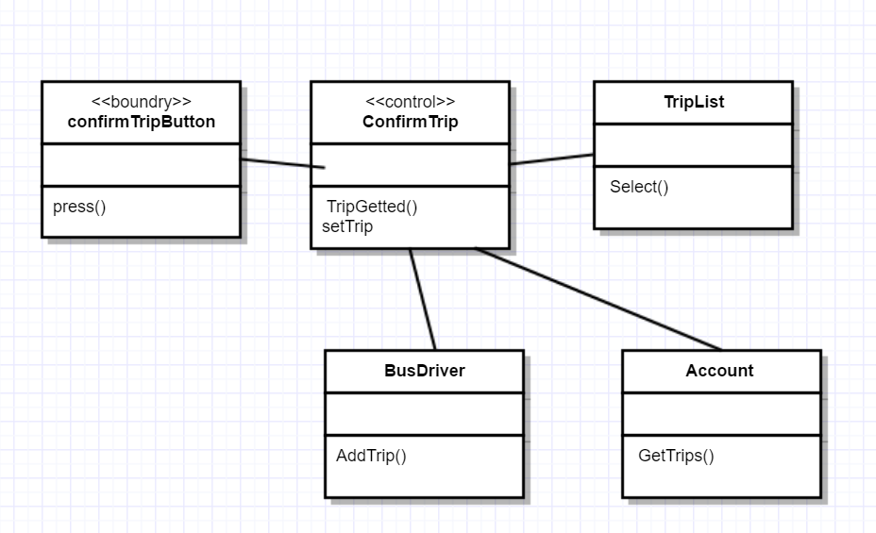

1.2.2 confirm Trip VOPC diagram

*Mock-ups:*

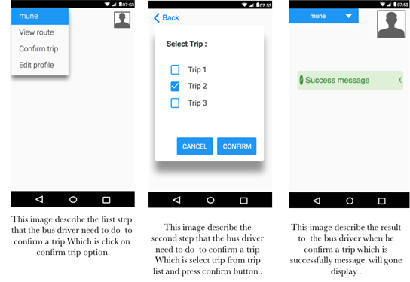

1.2.3 confirm Trip screen’s

**3rd use case , View Route:**

*Use case description :*

|  |  |  |
| --- | --- | --- |
|  | | |
| **SYSTEM:** The School Bus Monitoring and Management System (SBM2S) | | |
| **USE CASE NAME:** view route | | |
| **PRIMARY ACTOR:** bus driver | **SECONDARY ACTOR(S):**GPS system | |
| **DESCRIPTION:** This use case describe how the bus drive can view the routes to the students’ home on SBM2S. | | |
| **RELATIONSHIPS** INCLUDES: view the location of the bus in real time.. EXTENDS: route computed or regenerated. | | |
| **PRE-CONDITION:** - The bus driver must be registered and logged in onto the system successfully.  - check-in at least one student"in return trip". | | |
|  | | |
| **PRIMARY ACTOR (bus driver)** | **SYSTEM** | **SECONDARY ACTOR (GPS )** |
| 1.1 the bus driver clicks on “view route ” button.  1.5 the bus driver follow the guide lines until he's reach to destination.  1.7the bus-driver click on check-out button .  1.9 the bus-driver check OK . | 1.2 the system send checked-in student home's location to the GPS system. 1.4 the system generate line and direction to each distance.  1.6 the system pop up student name in arrive destination with check-out button .  1.8the system repeat 1.4-1.7 until the last destination then the system sends notify with end of rout to bus-driver .  1.10The system sends the bus-driver to home page and display a successful message. | 1.3 the GPS compute the locations in order of distance and return information to the system . |
| **ALTERNATIVE AND EXCEPTIONAL FLOWS:**  -On step 1.2 the system may have problems with connecting to GPS and sending students location.  - the bus driver may lose the internet connection hence the system can’s track his actual location and display in the map. | | |
| **POST-CONDITIONS:**  Successful condition the system displays map with clear directions , Failure Condition No rout appear for the bus-driver . | | |

*Sequence diagram:*

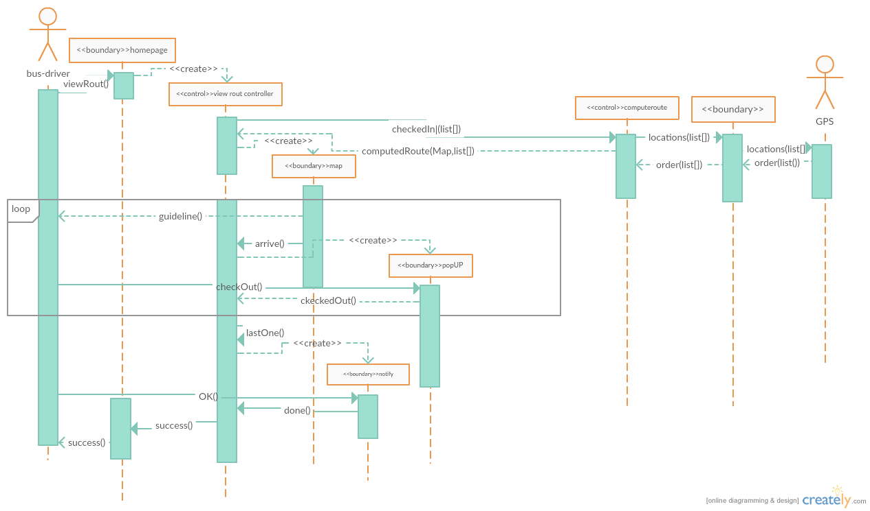

1.3.1 view Route sequence diagram

*VOPC diagram :*

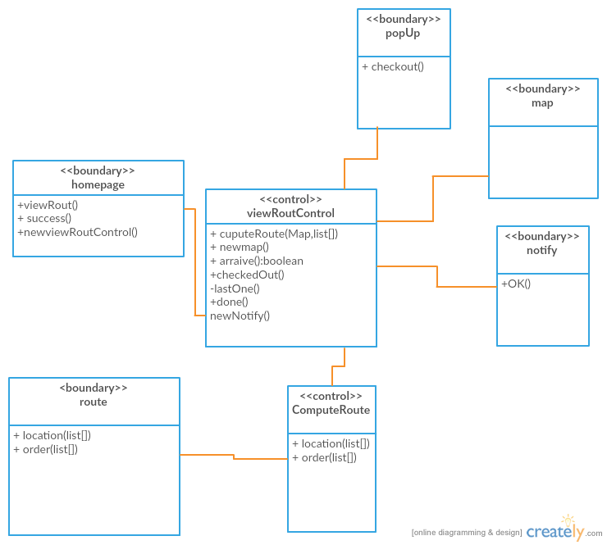

1.3.2 view Route VOPC diagram

*Mock-ups:*

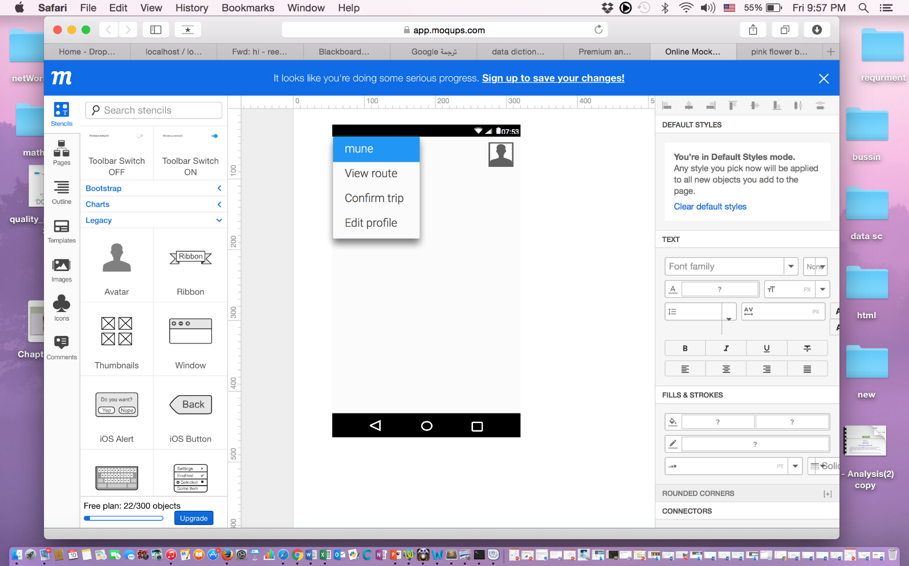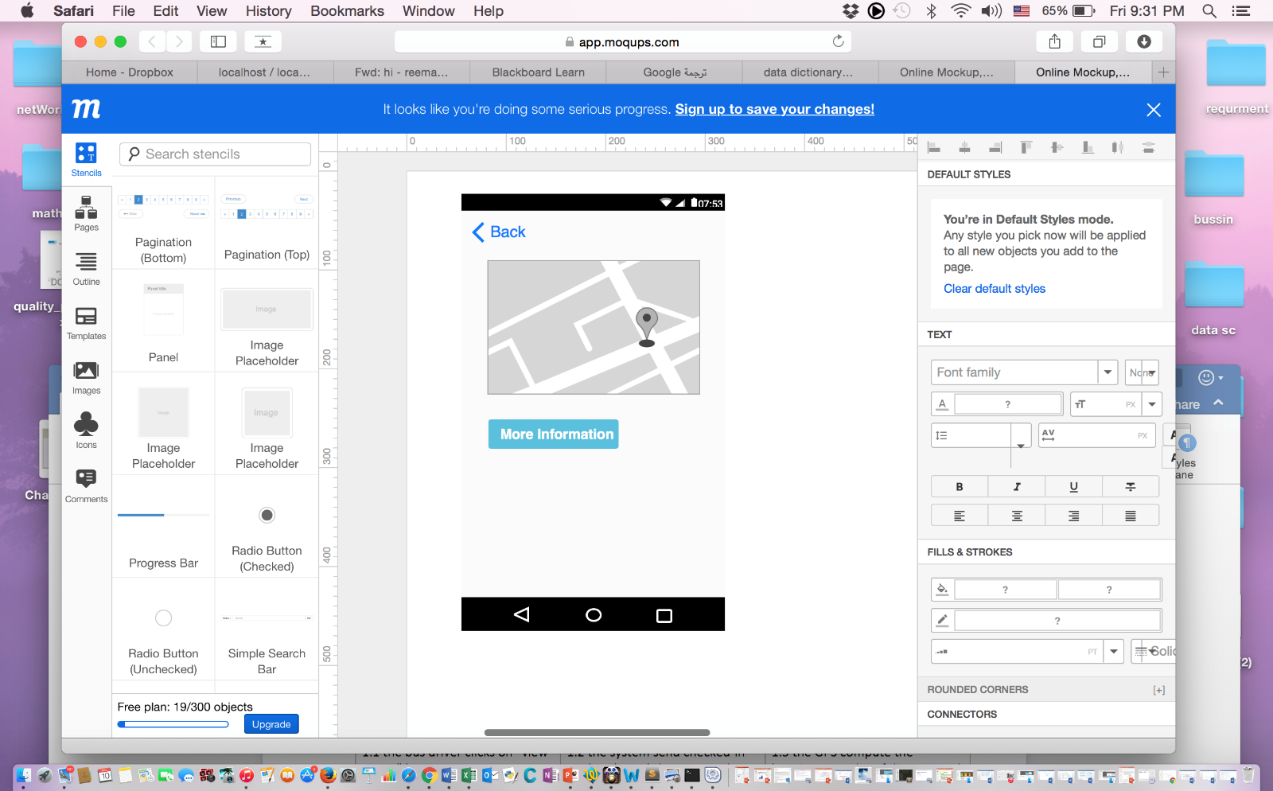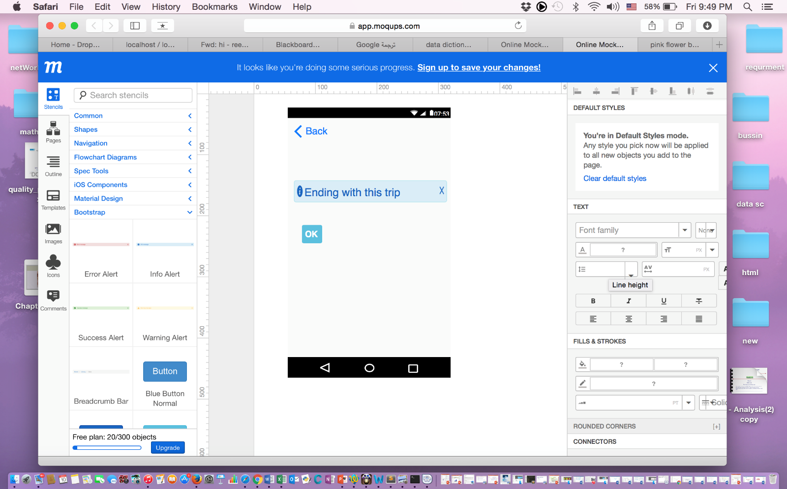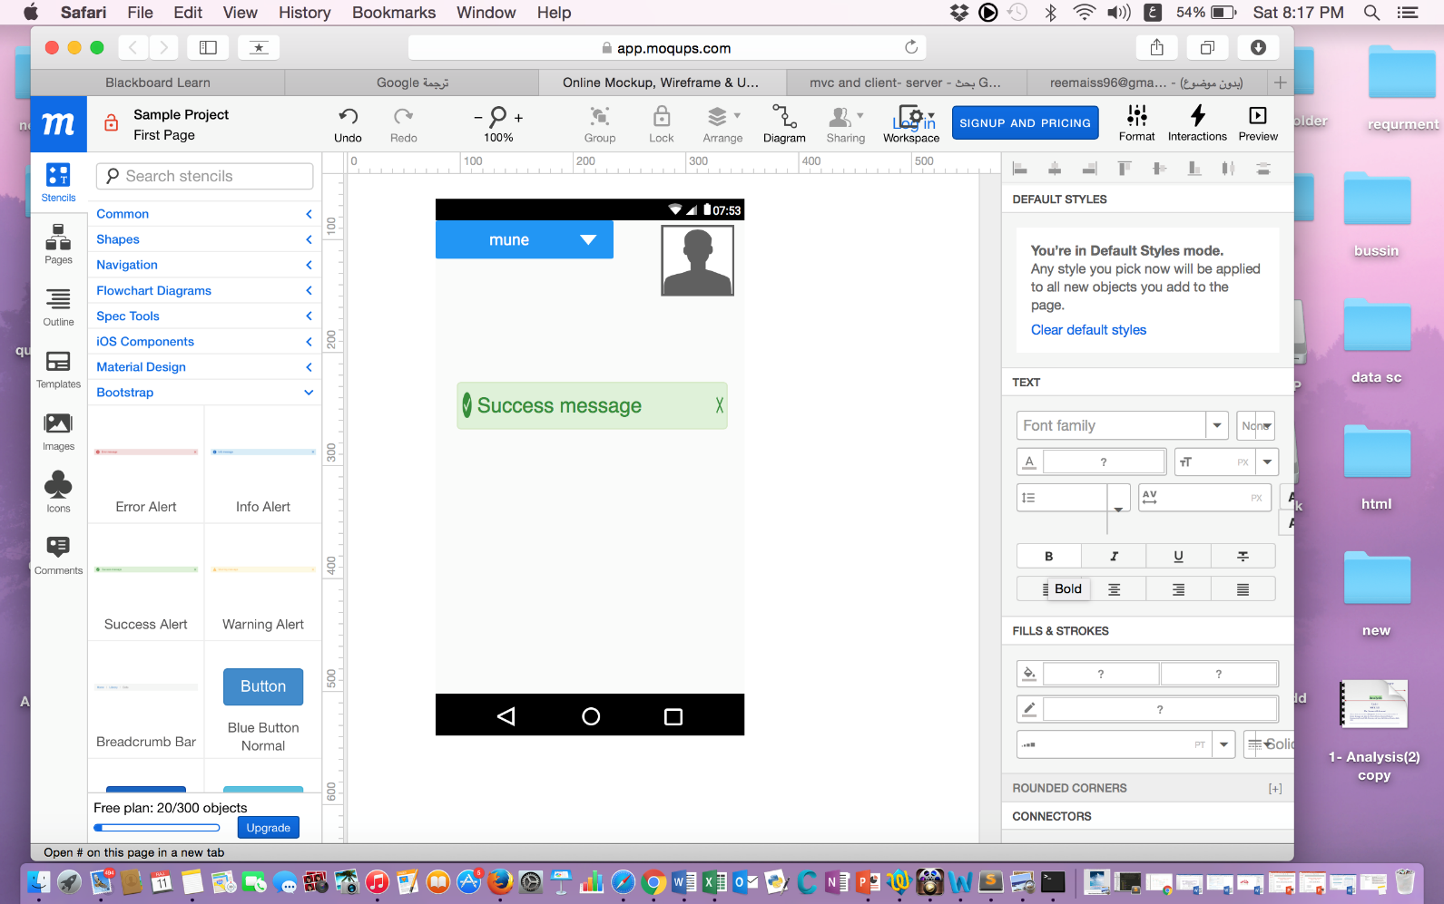

1.3.4click on view route 1.3.5 map display with directions 1.3.5 end of trip notification 1.3.6successful massage for end of trip

**4th use case, Inform absence :**

*Use case description :*

|  |  |  |  |  |
| --- | --- | --- | --- | --- |
| **Use Case Description** | | | | |
| **System: School Bus Monitoring and Management System** | | |  | |
| Use Case name: Inform absence | | |  | |
| Primary actor: Parent | Secondary actor(s): Admin, Bus driver | | | |
| Description: This use case describe how the parent can Inform absence for his/her child. | | | | |
| Relationships  Includes: none  Extends: none | | | | |
| Pre-conditions: The parent must be logged in successfully. | | | | |
| Steps: | | | | |
| Primary Actor (Admin) | | System | | Secondary Actor(s) (if applicable) |
| 1- The parent clicks on” Inform absence “button.  2- The parent fills the inform absence Form.  3- The parent clicks save. | | 1.1 The system displays inform absence Form.  3.1 The system displays a successful message  3.2 The system sends SMS message to the admin and notifies the bus driver of  student absence.  3.3 The system re-compute the routes for the parent’s child bus.  3.4 The system sends the new route to the bus driver. | |  |
| Alternative and exceptional flows:  1-Missing Field/ Incorrect Format:  1.1 If the parent did not fill the inform absence form correctly , then:  1.1.1 The system displays a notification for him/her .  1.1.2 Step 2 resumed.  1.2 If the parent closes the window before the page loads.  1.3 If the internet connection was lost. | | | | |
| POST-CONDITIONS:  Successful: Inform of student’s absence will be recorded successfully and the system will send  an SMS message to the bus driver and admin.  Failure: The system displays an error massage. | | | | |

*Sequence diagram:*

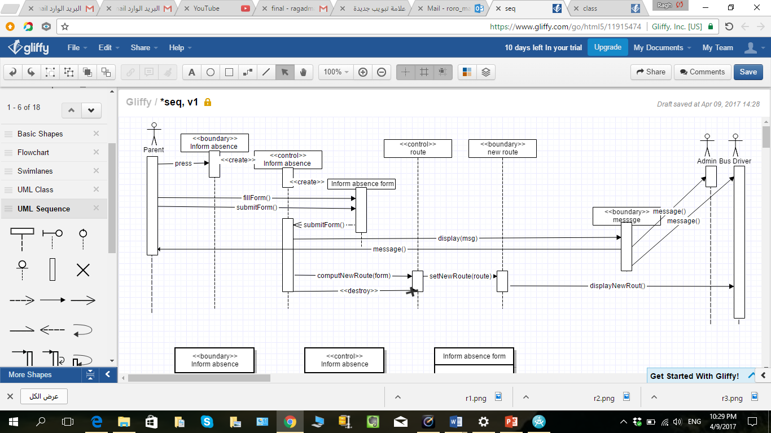 1.4.1inform absence sequence diagram

This image describe the Inform absence Sequence how the parent can Inform absence for his/her child

*VOPC diagram :*

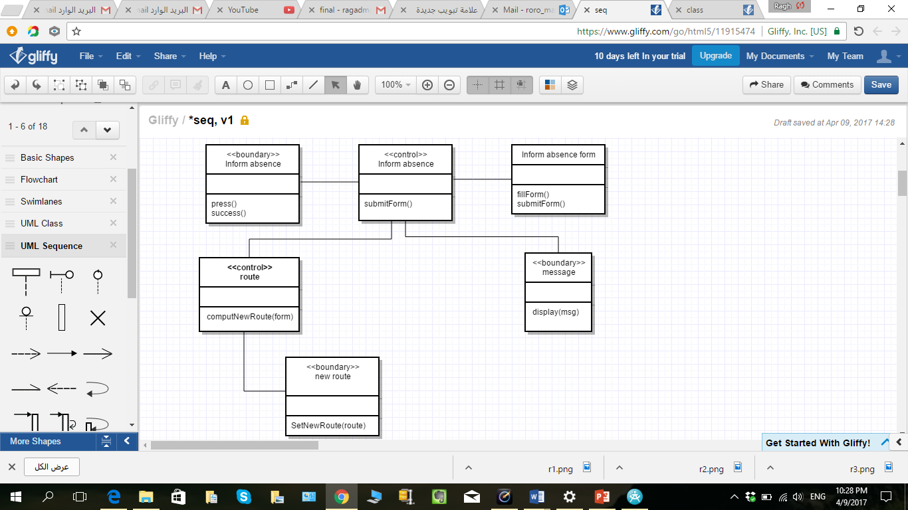

1.4.2inform absence VOPC diagram

*Mock-ups:*

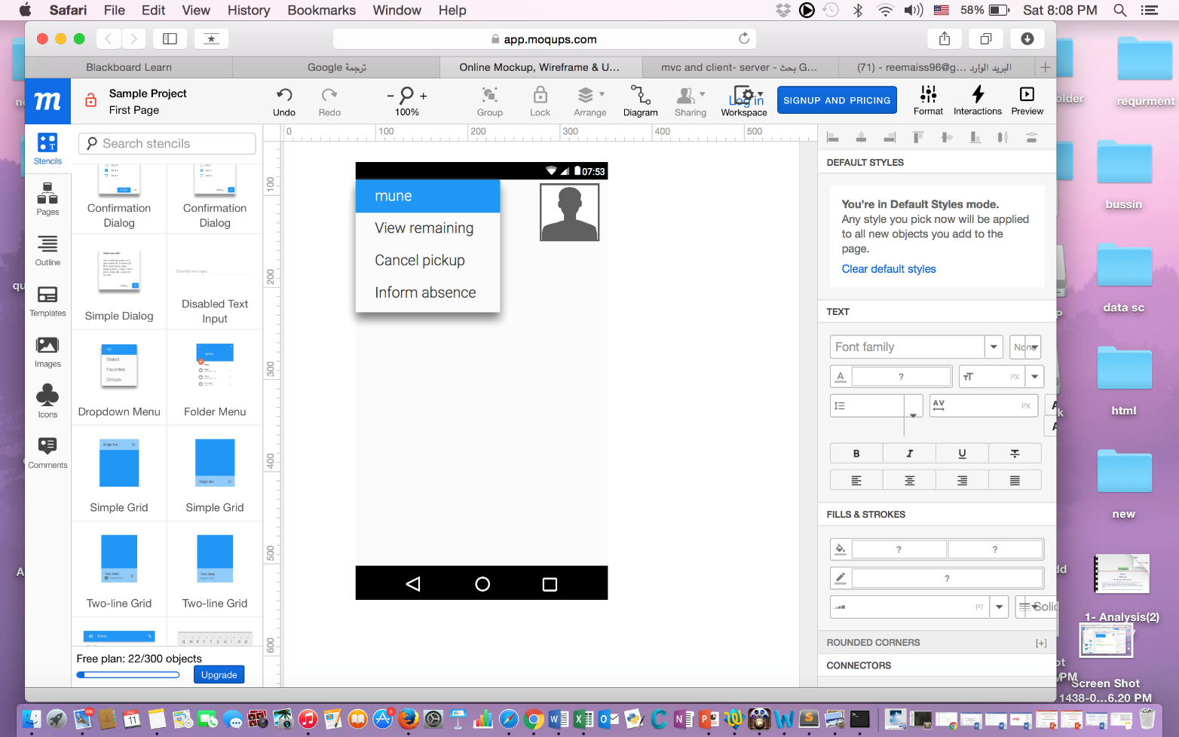

1.4.3

This image describe the first step that the parent need to inform absence Which is click on Inform absence option .

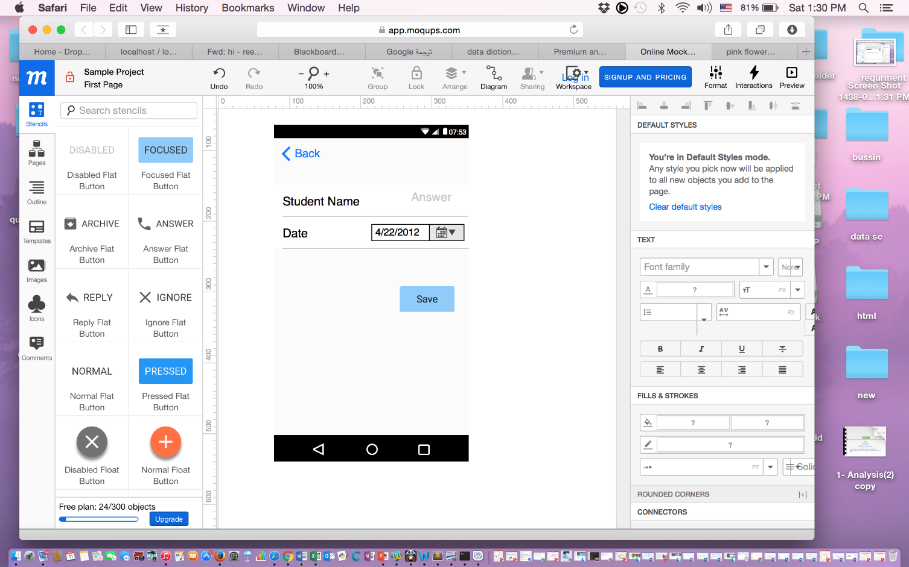

1.4.4

This image describe the second step that the parent need

to inform absence Which is fill “inform absence form” and click Save .

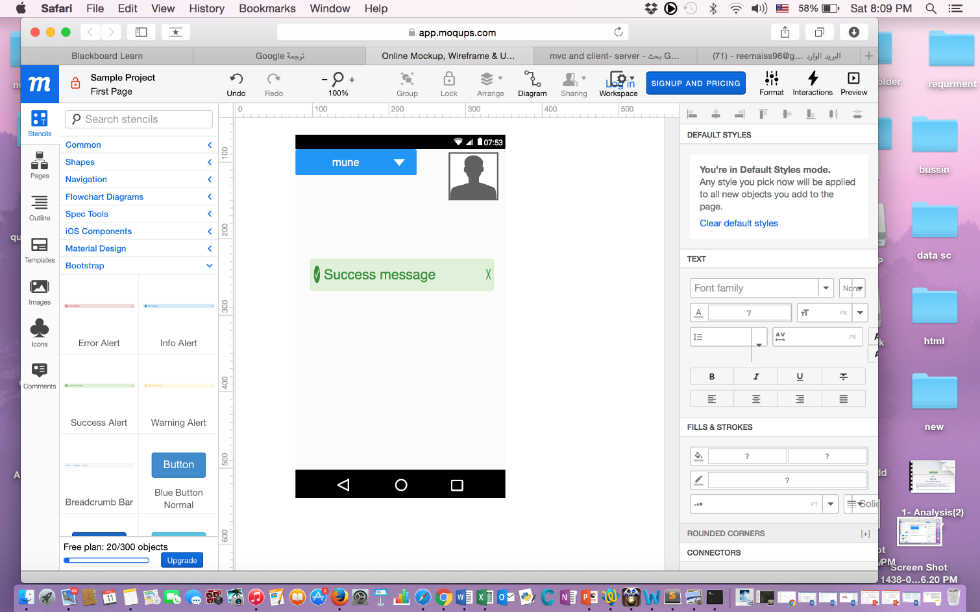

1.4.5

This image describe the result to the parent When he/she inform absence correctly which is successfully message will gone display.

**Class diagram :**

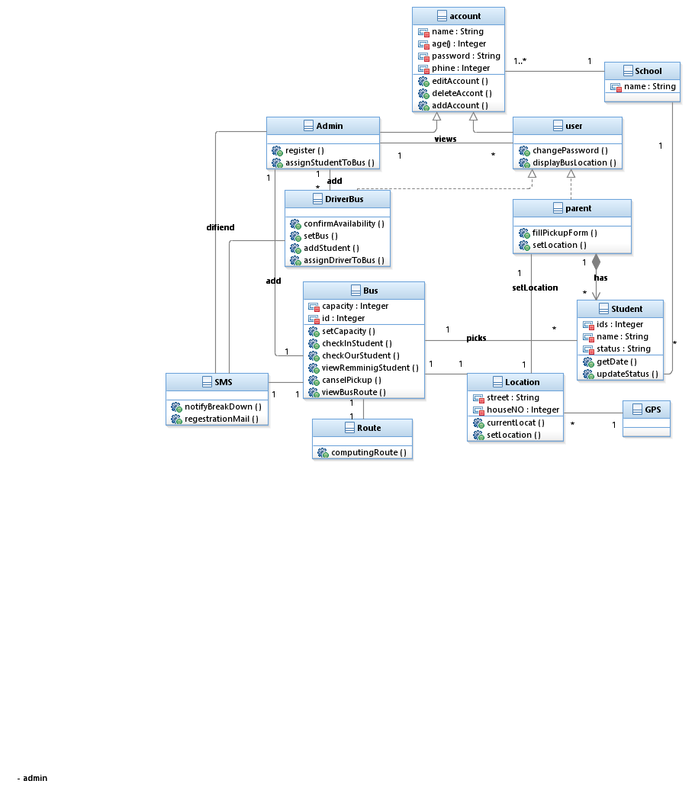

1.5class diagram

**Unified class diagram(VOPC) :** 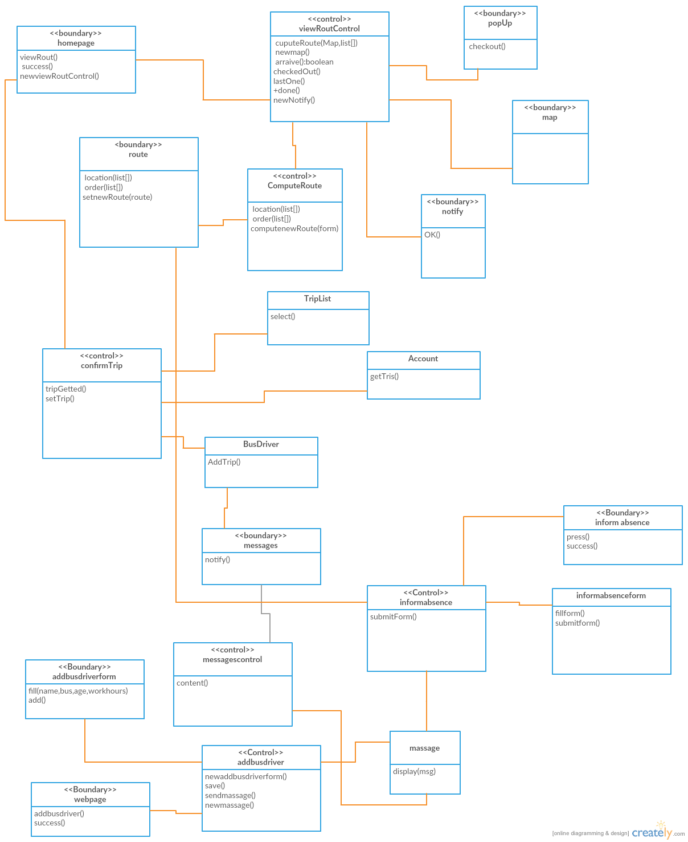

1.6

**State machine for trip object :**

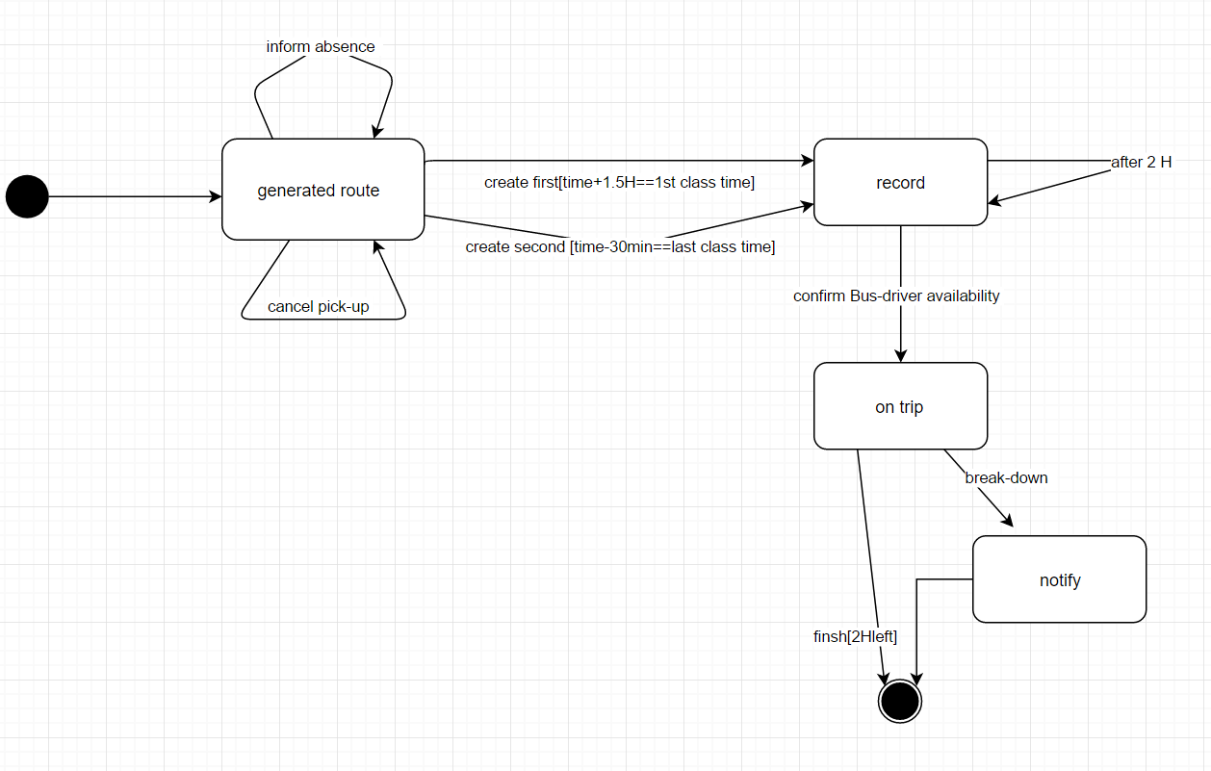

1.7state machine diagram

**most important two design goals:**

Security

The password for the bus driver and the parents should exceed 8 characters with the use of both upper-case and lower-case letters

Performance

The bus tracking system must respond to 99% of user requests within 3 seconds of the request

**The architecture style we have decided is :**MVC and Client/server styles

Server/Client: Segregates the system into two applications, where the client makes requests to the server. In many cases, the server is a database with application logic represented as stored procedures.

Our application is server based and will support many clients, we are creating Web-based applications exposed through a Web browser, and we are implementing a processes that will be used. The client/server architectural style is also suitable, like many networked styles, we choose this style because we want to centralize data storage, backup, and management functions, and our application must support different client types and different devices.

MVC because there is low coupling among models, views or controllers And Ease of modification - Because of the separation of responsibilities, future development or modification is easier( so we can Chang ease ) Also Multiple views for a model - Models can have multiple views (bus driver view , parint view) and The most important reason for choose MVC that the MVC has been widely adopted as an architecture for World Wide Web applications in major programming languages.

Why both :

MVC software frameworks vary in their interpretations, mainly in the way that the MVC responsibilities are divided between the client and server. Early web MVC frameworks took a thin client approach that placed almost the entire model, view and controller logic on the server. In this approach, the client sends either hyperlink requests or form input to the controller and then receives a complete and updated web page (or other document) from the view.

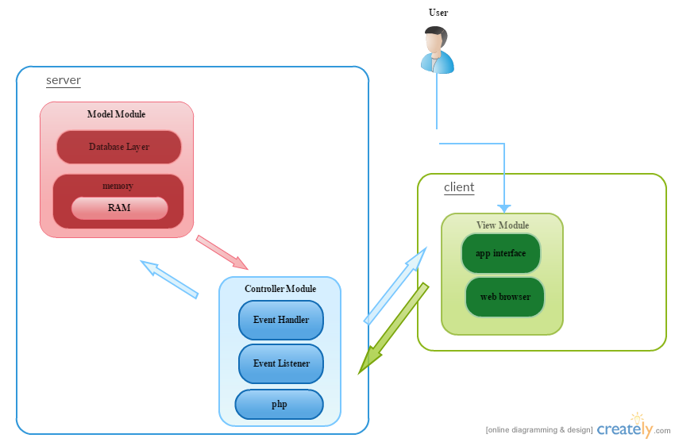

1.8 block diagram